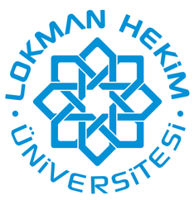
Lokman Hekim University Faculty of Medicine
2024-2025
Pre-Graduation Education Seminars Program

15/10/2024 | Seminars: " Contribution of electronic contuction by non-myocytes to cardiomyocyte electrical activity in insulin-resistant-heart"  Prof. Dr. Belma TURAN  Lokman Hekim University Medical School  Department of Biophysics
14/11/2024 | Seminars: ” Personalized oral care”  Dr. Sema Merve ALTINGÖZ  Lokman Hekim University Faculty of Dentistry
17/12/2024 | Seminars: “Risk groups in population: Vulnerable groups”  Prof. Dr. Gülsen GÜNEŞ  Lokman Hekim University Faculty of Medicine  Department of Public Health
17/1/2025 | Seminars: “The art of Anesthesiology”  Prof. Dr. Ülkü AYPAR  Lokman Hekim University Medical School  Department of Anestesiology and Reanimation
18/2/2025 | Seminars: “Strong Aging: Nutrition Strategies Against Sarcopenia in the Elderly”  Dr. Gökçen DOĞAN  Lokman Hekim University Faculty of Health Sciences  Department of Nutrition and Dietetics
17/3/2025 | Seminars: “Confidentiality”  Dr. Aydın GÜNDOĞMUŞ  Lokman Hekim Hospital  Department of Interventional Radiology
15/4/2025 | Seminars: "Artificial Researches in Medicine”  Güney Ali ÜNAL
29/4/2025 | Seminars: "One Health”  Prof. Dr. Sarp ÜNER  Lokman Hekim University Faculty of Medicine  Department of Public Health

